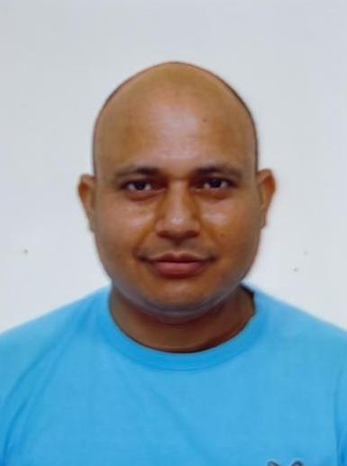

JAGMOHAN SINGH PANWAR

Address
501-10838
Whalley BLV
Surrey BC V3ROG8
Email ID- singhpanwarjagmohan@gmail.com
Phone.no: 2363325553

CAREER OBJECTIVE

To work in challenging Environment where I can put my potential to the best use of fulfilling organization goals & learning maximum in the process, through consistent hard work & resolute retaining of human values.

PROFESSIONAL EXPERIENCE

- Presently working with COLONELS KABABI INDIAN RESTAURANT & BAR LTD. as a Indian Cook From 8 Sep 2023 to till Date.

- Worked with NAMASTE INDIAN NEPAL Curry A. Unit of Nishan & Nirupum INTERNATIONAL Post Code 0620904 Toyohira Ku Sapporo Shi 4jo 3 Chome Hohai1-1 Floor Hokkaido Japan as a Indian Cook From June 2017 to 9th July 2023.

- Worked with ZARI ZARDOZI ALRAHA MALL ABUDHABI U.A.E. POST BOX 37005 as a Indian Cook from 25th August 2013 to 30th April 2017 .

- Worked with BJN Group Hotels Limited Luxurious & Fine Dining Restaurant, IIIrd Floor Ambience Mall, Gurgaon, as a Indian Cook from 01st Aug. 2009 to 10th July 2013.

- Worked with Citymax Hotels India Pvt. Ltd. The Yellow Chilli Luxurious & Fine Dining Restaurant (Sanjeev Kapoor Brand). As a Indian Tanbdoor Cook from 8th Feb. 2008 to 25th July 2009.

- Worked with Shalimar Bagh Club as a Indian Cook with effect 07th May 2007 to 02nd Feb. 2008.

- Worked with Badhai Banquet unit of Baldev Raj Bhandari & Sons, as a Indian Cook with effect form 12th April 2005 to 30th April 2007.

ACADEMIC QUALIFICATION

- Matriculation passed from U.P. Board in year 2001.
- Intermediate passed from U.A. Board in year 2003.

OTHER DETAILS

I am hard worker dedicate & honest, I believe in teamwork.
I am determined & devoted towards my work perseverance is my added quality I can handle adverse situation quite normally.

PERSONAL DETAILS

Father's Name : Shree Jot Singh Panwar
Name : Jagmohan Singh Panwar
Date of Birth : 26-March-1987
Hobbies : Cooking and Listening to music.
Marital status : Married
Language Known : Hindi, English
Permanent Address : Vill. Kaflana P/O Anjani Sain Distt.
Tehri Garhwal U.K.
Passport Number : M9976152
Date of Issue : 21.10.2015
Date of Expiry : 20.10.2025
Nationality : Indian

Date:
Place: (JAGMOHAN SINGH PANWAR)

